CAS PY 106

Prelecture Note 16

Force on a Wire

1. Force on a current-carrying wire
2. Magnetic field exerts a force on a single moving charge, so it’s not surprising that it exerts a force on a current-carrying wire, seeing as a current is a set of moving charges

F = q \* v \* B \* sin(theta)

q = I \* t (charge = current \* time)

F = I \* t \* v \* B \* sin(theta)

L = v \* t (length = velocity \* time)

F = I \* L \* B \* sin(theta), where L is the length of wire

1. Direction of the force is given by right-hand rule, where your fingers point in the direction of current
2. Current is defined to be the direction of flow of positive charges, so your right hand always gives the correct direction
3. Often, we imagine that wire is very long, so we calculate force per unit length on the wire:

F/L = I \* B \* sin(theta)

1. Producing a magnetic field
2. Magnetic fields are produced by moving charges
3. In practice, we generally produce magnetic fields from currents
4. Magnetic field from a long straight wire
5. A long straight current-carrying wire, for magnetism, is analogous to the point charge for electric fields
6. 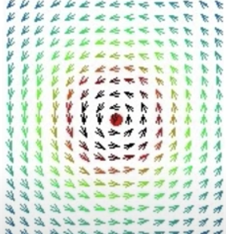
7. Red dot in the middle implies wire carrying a current out of the screen
8. Magnetic field a distance r from a wire with current I is

B = u \* I / 2pi(r)

u, the permeability of free space, is 4pi \* 10^-7

1. Magnetic field lines from a long straight current-carrying wire are circular loops centered on the wire
2. The force between two wires
3. In this situation, opposites repel and likes attract
4. Parallel currents going the same direction attract
5. If they are in opposite directions, they repel
6. 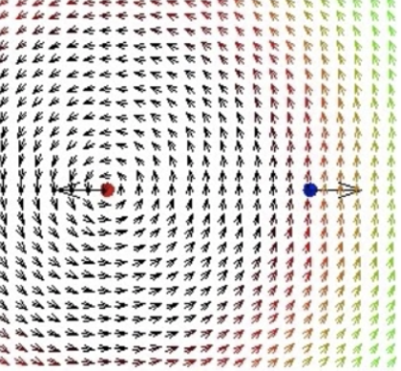
7. Force per unit length on wire 2 by wire 1:

F21/L = I2\*B1

Field from wire 1: B1 = u \* I1 / 2pi(r)

Force per unit length = F21/L = u \* I1\*I2/2pi(r)

1. Wire feels more force
2. 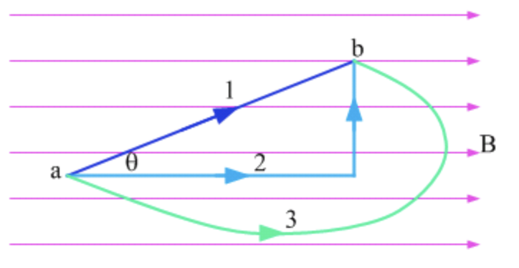
3. Which wire feels the most force?

F = I\*L\*B\*sin(theta)

1. All wires have the same magnetic field B and current
2. Force depends on the length \* sin(theta)

For wires 1 and 2, L1\*sin(theta) = L2, therefore F1=F2

F3=F2 because if the long wire 3 is broken down into smaller segments, some parallel to the field (experience no force) and some perpendicular to the field. Segments carrying current down cancels out the segments carrying the current up, leaving the net force to come from segments that add up to the force on the perpendicular side of wire 2.

Therefore, all wires experience the same force